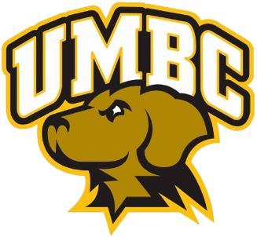

**University of Maryland, Baltimore County**

Recreation & Club Sports 

**Visiting Team Guide**

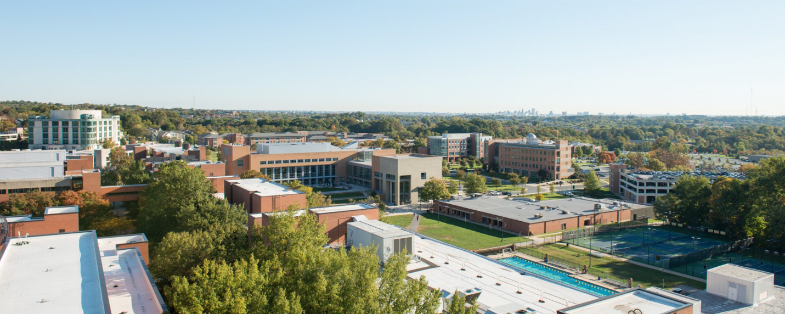

Welcome

The University of Maryland, Baltimore County (UMBC) would like to welcome you to our campus! This guide has been designed to provide you with useful information about our facilities and the area. We hope it proves useful in planning your trip to the UMBC Campus.

UMBC Club Sports Contacts

The student officers and leaders from each club are your main source of communication for all event related information and logistics. Club contact information is provided on the second page of this guide. However, our staff is also here to assist you.

Dominic French

Assistant Director, Club Sports

frenchd2@umbc.edu, 410-455-1540

Jasmine Holmes

Associate Athletic Director, Recreation & Physical Education

jholmes5@umbc.edu, 410-455-2638

Manager of Duty & RAC Front Desk

410-455-8888

Club Sport Directory

| **Club Sport** | **President** | **Email** |
| --- | --- | --- |
| Badminton | Donovan Fey | dfey1@umbc.edu |
| Crew | Aum Chorida | sl06778@umbc.edu |
| Esports | Dustin Nguyen | dnguye10@umbc.edu |
| Fencing | Milan Valderrama | milanv1@umbc.edu |
| Golf | Weston Blottenberger | westonb1@umbc.edu |
| Ice Hockey | Julius Rubin | jrubin3@umbc.edu |
| Jujitsu | Andrew Fulco | afulco1@umbc.edu |
| Men's Lacrosse | Oliver Woodgett | o78@umbc.edu |
| Women's Lacrosse | Jessica Hoffman | jhoffma3@umbc.edu |
| Pickleball |  |  |
| Men's Rugby | Nate Cullen | ncullen1@umbc.edu |
| Women's Rugby | Keira Tavai | ktavai1@umbc.edu |
| Running | Cole Na | cna1@umbc.edu |
| Sailing |  |  |
| Men's Soccer | Viktor Struck | vstruck1@umbc.edu |
| Women's Soccer | Jesse Leipold | jleipol1@umbc.edu |
| Tae Kwon Do | Hanah You | hyou1@umbc.edu |
| Tennis | Aswanth Jeyaram Kumar | ajeyara1@umbc.edu |
| Men's Ultimate Frisbee | Ethan Dudash | ethand4@umbc.edu |
| Women's Ultimate Frisbee | Sae Egoshi | segoshi1@umbc.edu |
| Men's Volleyball | Kyle Geary | kgeary1@umbc.edu |
| Women's Volleyball | Ashley Chen | achen20@umbc.edu |
| Wrestling | Henry Sonti | hsonti1@umbc.edu |
| Wushu | Riddhi Patel | rpatel24@umbc.edu |

Important Information

* All visiting teams are required to adhere to all federal, state, and University laws, guidelines, standards, and policies.
* Respect all UMBC students, professional staff, and the decisions they make.
* Alcohol is not permitted in or at any UMBC facility. This includes all indoor and outdoor sporting facilities on campus.
* UMBC is a smoke-free campus.
* Follow all posted parking regulations. UMBC is not responsible for parking fines. Please check with your host for parking guidelines.
* Practice good sporting behavior and act in a positive, mature, and responsible manner. The actions of your team and your fans are a reflection of your university and club sport program.
* Please use the trash and recycling receptacles provided. Clean up after yourselves. Leave the space cleaner than you found it.
* Participants under the age of 18 or not currently affiliated with the university team must complete a waiver on site.

Parking

Visiting teams are encouraged to use the UMBC Club Sports Map at

<https://recreation.umbc.edu/club-sports/visiting-team-guide/>. The interactive map hosted by Google provides locations for on campus facilities and parking locations.

Driving Directions to UMBC

**Campus Address**

1000 Hilltop Circle

Baltimore, MD 21250

**From Philadelphia and Points North**Take I-95 S towards Baltimore (Toll road). Take exit 47A-B toward MD-166 N/Catonsville. At the split merge onto MD-166. Stay in the right lane to merge onto UMBC campus/UMBC Blvd. At the traffic circle take the 2nd exit.

[Directions from Philadelphia to UMBC](https://www.google.com/maps/dir/Philadelphia,+PA/1000+Hilltop+Circle,+Baltimore,+MD/@39.5934276,-76.4893,9z/data=!3m1!4b1!4m13!4m12!1m5!1m1!1s0x89c6b7d8d4b54beb:0x89f514d88c3e58c1!2m2!1d-75.1652215!2d39.9525839!1m5!1m1!1s0x89c81dcbd9b9006b:0xafba780534969a7d!2m2!1d-76.714273!2d39.253802)

**From Washington DC and Points South**Take I-495E/Beltway ramp to Baltimore. Take exit 27 for I-95N toward Baltimore. Take exit 47A-B toward MD-166/Catonsville. Merge onto I-195W, continue onto MD-166. Take the UMBC campus exit. Continue onto UMBC Blvd. At the traffic circle take the 2nd exit.

[Directions from Washington DC to UMBC](https://www.google.com/maps/dir/Washington,+DC/1000+Hilltop+Circle,+Baltimore,+MD/@39.0767619,-77.0037414,11z/am=t/data=!3m1!4b1!4m14!4m13!1m5!1m1!1s0x89b7c6de5af6e45b:0xc2524522d4885d2a!2m2!1d-77.0368707!2d38.9071923!1m5!1m1!1s0x89c81dcbd9b9006b:0xafba780534969a7d!2m2!1d-76.714273!2d39.253802!5i1)

**From Roanoke, VA and Points West**Take I-81N toward Lexington. Take exit 300 for I-66 toward Front Royal/Washington. Follow signs for I-495 exit toward Richmond/Baltimore. Keep right at the fork and follow signs for I-495N/Baltimore. Take exit 27 for I-95N toward Baltimore. Take exit 47A-B toward MD-166/Catonsville. Merge onto I-195W, continue onto MD-166. Take the UMBC campus exit. Continue onto UMBC Blvd. At the traffic circle take the 2nd exit.

[Directions from Roanoke, VA to UMBC](https://www.google.com/maps/dir/Roanoke,+VA/1000+Hilltop+Circle,+Baltimore,+MD/@38.3325654,-79.4720027,8z/am=t/data=!3m1!4b1!4m13!4m12!1m5!1m1!1s0x884d0c4d6aa966fd:0x249dbecbdbb0989b!2m2!1d-79.9414266!2d37.2709704!1m5!1m1!1s0x89c81dcbd9b9006b:0xafba780534969a7d!2m2!1d-76.714273!2d39.253802)

**From Dover, DE and Points East**Take US-301 S toward Baltimore. Continue onto I-97 N, follow signs for I-695 W/Baltimore/Towson. Take exit 12C toward Md-372 W/Wilkens Ave. Turn right onto Kenwood Ave. (signs for Wilkens Ave/MD-372). Turn right onto Wilkens Ave. (signs for 12C W). At the traffic circle, take the 3rd exit. Continue onto Hilltop Rd.

[Directions from Dover, DE to UMBC](https://www.google.com/maps/dir/Dover,+DE/1000+Hilltop+Circle,+Baltimore,+MD/@39.3501077,-76.3838448,10z/am=t/data=!3m1!4b1!4m13!4m12!1m5!1m1!1s0x89c7633375685ead:0xa9e2e447fb006cf0!2m2!1d-75.5243682!2d39.158168!1m5!1m1!1s0x89c81dcbd9b9006b:0xafba780534969a7d!2m2!1d-76.714273!2d39.253802)

Facilities

**Retriever Activities Center (RAC)**

Located off Administration Drive on campus, the RAC is home to competitions for Men’s & Women’s Club Volleyball, Wrestling, Badminton, Pickleball, Jujitsu, Fencing, Tae Kwon Do and Wushu. Inside you’ll find the UMBC Club Sports office (RAC 252), a track, fitness studio, weight room, arena court, rubberized multi-purpose courts, indoor & outdoor pool, locker/shower facilities, and professional staff offices. A valid UMBC ID card is required for admittance. Visiting club sport teams and spectators are required to sign a waiver to enter the facility and are restricted to the space reserved for the club event. Unauthorized use of other facility space is prohibited. 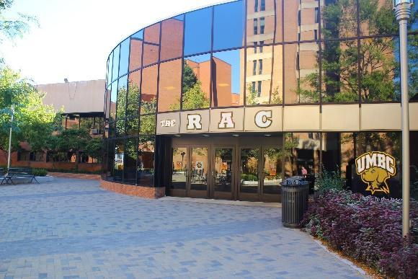



**RAC Tennis Courts**

Located off Administration Drive on campus, these 6 tennis courts accommodate the Club Tennis, Club Pickleball, Physical Education classes and informal tennis play. Weather permitting. 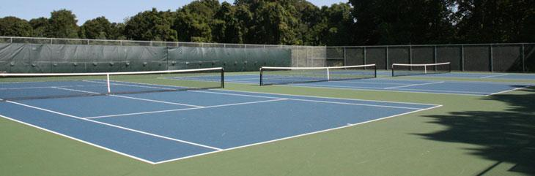



**Walker Field**

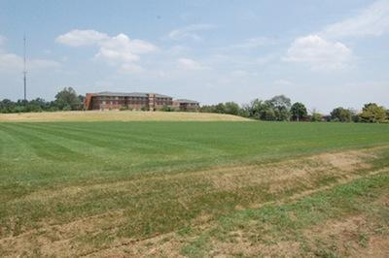

Located off Hilltop road on campus, the field is home to competitions/practices for Men’s and Women’s Club Rugby.



**UMBC Stadium Complex**

Located off Hilltop circle on campus, this lighted artificial turf and track is home to competitions for Men’s & Women’s Club Lacrosse, Men’s & Women’s Club Soccer, Men’s & Women’s Ultimate Frisbee, and Running Club.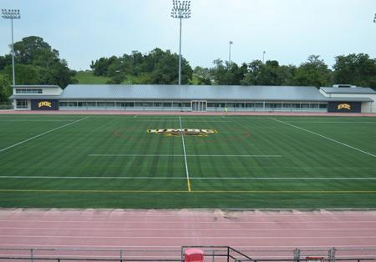



**Fields 1 & 2 - Shelbourne Road**

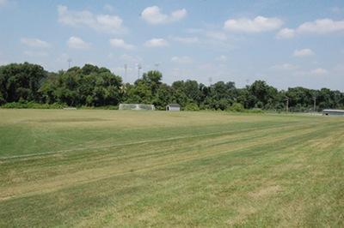

Located just off campus on Shelbourne Road across from Arbutus Middle School, these two grass fields are home to competitions for Men’s & Women’s Club Soccer and Men’s & Women’s Ultimate Frisbee.



**The Gardens Ice House**

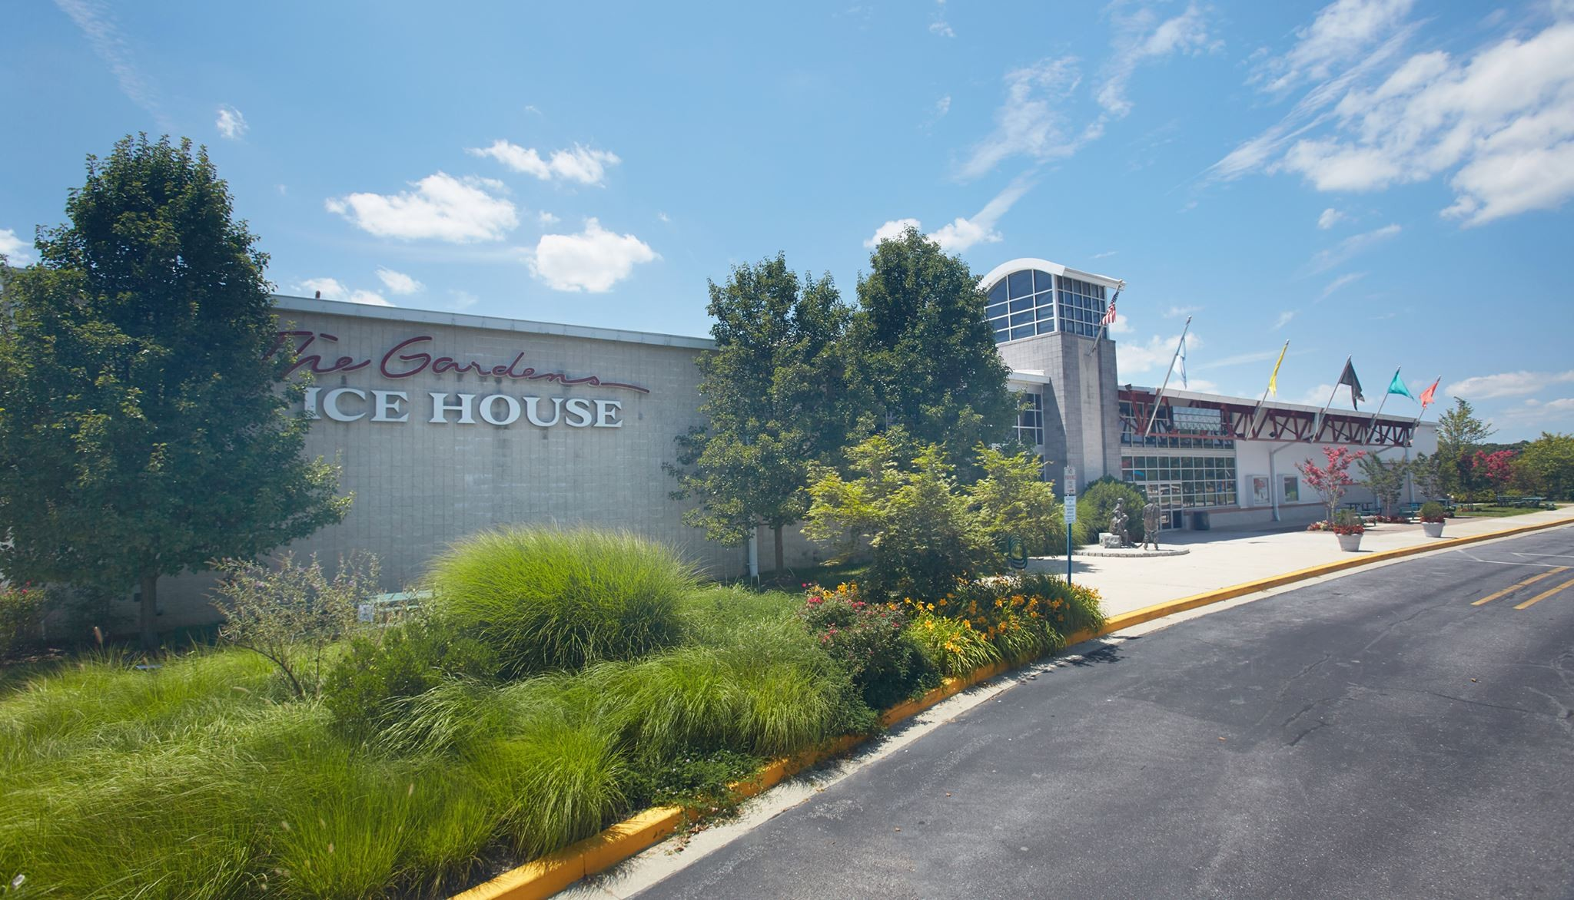

Located off-campus at 13800 Old Gunpowder Rd #2fl, Laurel, MD 20707, this 150,000 sq/ft skating facility is home to Ice Hockey.

For more information, visit [The Gardens Ice House](https://www.thegardensicehouse.com/).



Inclement Weather

* In the event of inclement weather the game Supervisor will determine when to halt play and will help direct participants and spectators to the nearest shelter for safety.

Incidents, Injuries, & Emergencies

To ensure that we provide a safe and secure environment for our participants:

* A Safety Supervisor is onsite for all competitions.
* A UMBC Club Sports Supervisor is onsite for all competitions.
* Anytime a participant is injured in/at a UMBC facility a UMBC Club Sports Incident Report must be completed. In the event of an injury, please see the UMBC supervisor designated for that event. These individuals will be able to complete the Incident form and facilitate care.
* In the event of a medical emergency the Athletic Trainer on site will call campus police, 410-455-5555. Campus police will call for an ambulance.

Local Hospitals and Medical Centers

**St. Agnes Hospital**   
900 S. Caton Ave.   
Baltimore, MD 21229  
667-234-6000

[https://healthcare.ascension.org/](https://healthcare.ascension.org/locations/maryland/mdbal/baltimore-ascension-saint-agnes-hospital)  
*Hours:* Open 24 hours  
*Driving Directions from Campus:* Head west on Hilltop Rd toward Hilltop Circle. At the traffic circle, take the 1st exit onto MD-372 E/Wilkins Ave. Use any lane to turn left onto Southwestern Blvd. Continue onto Wilkins Ave, then turn right onto S. Caton Ave. The hospital will be on your left.

**Patient First – Catonsville**6333 Baltimore Nationals Pike   
Catonsville, MD 21228  
443-514-1361

[https://www.patientfirst.com/](https://www.patientfirst.com/locations/baltimore/catonsville)  
*Hours:* Open from 8am to 8pm; everyday, including weekends and holidays*Driving Directions from Campus:*Head west on Hilltop Rd toward Hilltop Circle. At the traffic circle, take the 1st exit onto MD-372 E/Wilkins Ave. Turn left onto Kenwood Ave. Turn left to merge onto I-695 N toward Towson. Take exit 15B to merge onto US-40 W/Baltimore National Pike toward Ellicott City. Travel 1.5 miles and destination will be on your left.

Local Attractions

**Baltimore**  
Only 10 miles from the university, Baltimore has something for everyone. Built around the Inner Harbor, the city is a walker’s delight, with a lineup of attractions within three or four blocks of one another. More information can be found at [www.baltimore.org](http://www.baltimore.org).

**Annapolis**  
Only 30 miles from the university, Annapolis boasts historic charm with its beautifully preserved and restored buildings and brick downtown streets. A boater’s paradise, the city ranks as the Sailing Capital of America and hosts the country’s largest in-water boat show every October. More information can be found at [www.visit-annapolis.org](http://www.visit-annapolis.org).

**Washington, DC**  
Only 40 miles from the university, Washington, DC, is a metropolitan city with historic attractions, museums, monuments, hotels, restaurants, free annual events, and visitor’s services unrivaled by any other American city. More information can be found at [www.washinton.org](http://www.washinton.org).

Important Links

* [UMBC Visitors Guide](https://umbc.edu/about/visit/)
* [Campus Maps](https://umbc.edu/about/visit/directions/)
* [Visitor Parking](https://parking.umbc.edu/pay-stations/)
* [UMBC Recreation Website](http://recreation.umbc.edu/)
* [UMBC Club Sports Website](http://recreation.umbc.edu/club-sports)
* [UMBC Website](http://www.umbc.edu/)