University of Maryland, Baltimore County
Recreation & Club Sports

Visiting Team Guide
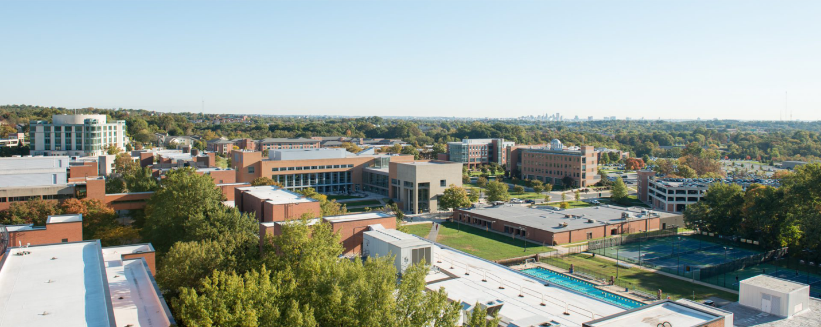
Welcome
The University of Maryland, Baltimore County (UMBC) would like to welcome you to our campus! This guide has been designed to provide you with useful information about our facilities and the area. We hope it proves useful in planning your trip to the UMBC Campus.

UMBC Club Sports Contacts
The student officers and leaders from each club are your main source of communication for all event related information and logistics. Club contact information is provided on the second page of this guide. However, our staff is also here to assist you.

Kristen Alexander
Assistant Director of Club Sports
Kristen2@umbc.edu, 410-455-2205

Gary Wohlstetter
Senior Associate A.D., Recreation & Physical Education
wohlstet@umbc.edu, 410-455-2638

Manager of Duty & RAC Front Desk
410-455-8888

Club Sport Directory

Club Sport | Name | Email
Aikido | Ethan Crookshank | Crook2@umbc.edu
Crew | Fernando Morales | Fer1@umbc.edu
Cycling | Kurt Hamblin | hamblin2@umbc.edu
Equestrian | Maya Scheirer | Maya8@umbc.edu
Fencing | Patrick Offenbacher | umbcfencing@gmail.com
Jujitsu | Amy McNamara | Mcnamar1@umbc.edu
Paintball | Sheldon Kinsler | Skin1@umbc.edu
Running | Julia Ciattei | jcia@umbc.edu
Sailing | William Gao | wgao1@umbc.edu
Tae Kwon Do | Michael Daugherty | mda1@umbc.edu
Tennis | Kaitlyn Heo | kaiheo1@umbc.edu
Wrestling | Peter Tyler Rendina | Redndina1@umbc.edu
Wushu / Taichi | Irene Javier | ijavier1@umbc.edu
Ice Hockey | N/A | N/A
Men's Lacrosse | Brian Spiegel | spiegel1@umbc.edu
Men's Rugby | Jacob Rampolla | jramp1@umbc.edu
Men's Soccer | David Choi | choidav1@umbc.edu
Men's Ultimate Frisbee | Derek Frazer | derekf3@umbc.edu
Men's Volleyball | Brian Lee | blee13@umbc.edu
Women's Lacrosse | Tyler Stephen | Taylor24@umbc.edu
Women's Rugby | Sophie Peet | peet2@umbc.edu
Women's Soccer | Michelle Innerarity | mi24@umbc.edu
Women's Ultimate Frisbee | Tina Hoffman | choffma1@umbc.edu
Women's Volleyball | Lenna Meyer | lmeyer4@umbc.edu

Important Information
- All visiting teams are required to adhere to all federal, state, and University laws, guidelines, standards and policies.
- Respect all UMBC students/professional staff and the decisions they make.
- Follow all posted parking regulations. UMBC is not responsible for parking fines. Please check with your host for parking guidelines.
- Practice good sportsmanship and act in a positive, mature and responsible manner. The actions of your team and your fans are a reflection of your university and club sport program.
- Alcohol is not permitted in/at any UMBC facility. This includes all indoor and outdoor sporting facilities on campus.
- Please use the trash and recycling receptacles provided. Clean up after yourselves. Leave the space cleaner then you found it.
- UMBC is a smoke free campus.
- Participants under the age of 18 or not currently affiliated with the university team, must complete a waiver (see Appendix)

Interactive Map
Visiting teams are encouraged to use the UMBC Club Sports Map at
www.recreation.umbc.edu/club-sports/visiting-team-guide/. The interactive map hosted by google provides locations for on and off campus facilities, parking, and area amenities such as medical facilities, food and lodging. In some cases additional information is provided such as contacts for local hotels, restaurants, medical facilities and parking regulations. Whether you are on-site or just planning your trip, this tool will come in handy!

Driving Directions to UMBC
Campus Address
1000 Hilltop Circle
Baltimore, MD 21250

From Philadelphia and Points North
Take I-95 S towards Baltimore (Toll road). Take exit 47A-B toward MD-166 N/Catonsville. At the split merge onto MD-166. Stay in the right lane to merge onto UMBC campus/UMBC Blvd. At the traffic circle take the 2nd exit.
Directions from Philadelphia to UMBC

From Washington DC and Points South
Take I-495E/Beltway ramp to Baltimore. Take exit 27 for I-95N toward Baltimore. Take exit 47A-B toward MD-166/Catonsville. Merge onto I-195W, continue onto MD-166. Take the UMBC campus exit. Continue onto UMBC Blvd. At the traffic circle take the 2nd exit.
Directions from Washington DC to UMBC

From Roanoke, VA and Points West
Take I-81N toward Lexington. Take exit 300 for I-66 toward Front Royal/Washington. Follow signs for I-495 exit toward Richmond/Baltimore. Keep right at the fork and follow signs for I-495N/Baltimore. Take exit 27 for I-95N toward Baltimore. Take exit 47A-B toward MD-166/Catonsville. Merge onto I-195W, continue onto MD-166. Take the UMBC campus exit. Continue onto UMBC Blvd. At the traffic circle take the 2nd exit.
Directions from Roanoke, VA to UMBC

From Dover, DE and Points East
Take US-301 S toward Baltimore. Continue onto I-97 N, follow signs for I-695 W/Baltimore/Towson. Take exit 12C toward Md-372 W/Wilkens Ave. Turn right onto Kenwood Ave. (signs for Wilkens Ave/MD-372). Turn right onto Wilkens Ave. (signs for 12C W). At the traffic circle, take the 3rd exit. Continue onto Hilltop Rd.
Directions from Dover, DE to UMBC

Facilities
Retriever Activities Center (RAC)
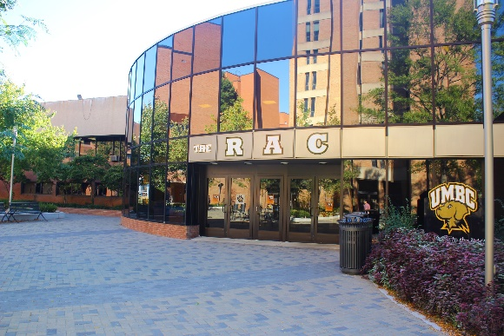
Located off Administration Drive on campus, the RAC is home to competitions for Men’s & Women’s Volleyball, Wrestling, Jujitsu, Aikido, Fencing, Tae Kwon Do and Wushu. Inside you’ll find the UMBC Club Sports office (RAC 321), a track, fitness studio, weight room, rubberized basketball courts, indoor & outdoor pool, locker/shower facilities, the main arena (where the UMBC NCAA Division 1 teams compete) and professional staff offices. A valid UMBC ID card is required for admittance. Visiting club sport teams and spectators are restricted to the space reserved for the club event. Unauthorized use of other facility space is prohibited.
RAC Tennis Courts
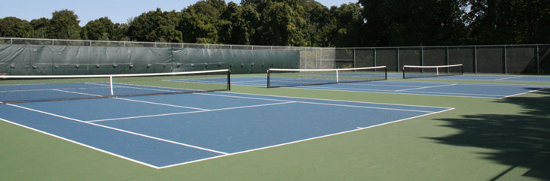
Located off Administration Drive on campus, these 6 tennis courts accommodate the club tennis, physical education classes and informal tennis play. Weather permitting.

Walker Field

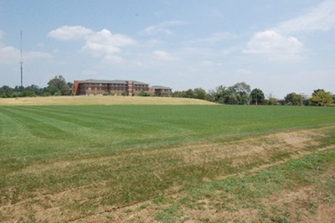
Located off Hilltop road on campus, the field is home to competitions/practices for Club Men’s and Women’s Rugby.

UMBC Stadium Complex
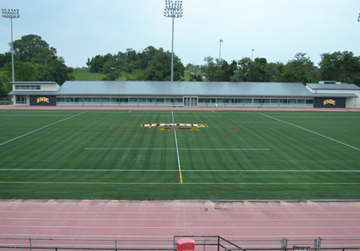
Located off Hilltop circle on campus, this lighted artificial turf is home to competitions for Men’s & Women’s Lacrosse, Men’s & Women’s Soccer and Men’s & Women’s Ultimate Frisbee.

Fields 2 & 3/Shelbourne Road

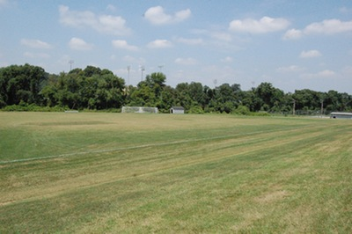
Located just off campus on Shelbourne Road across from Arbutus Middle School, these two grass fields are home to competitions for Men’s & Women’s Soccer and Men’s & Women’s Ultimate Frisbee.

Reisterstown Sportsplex

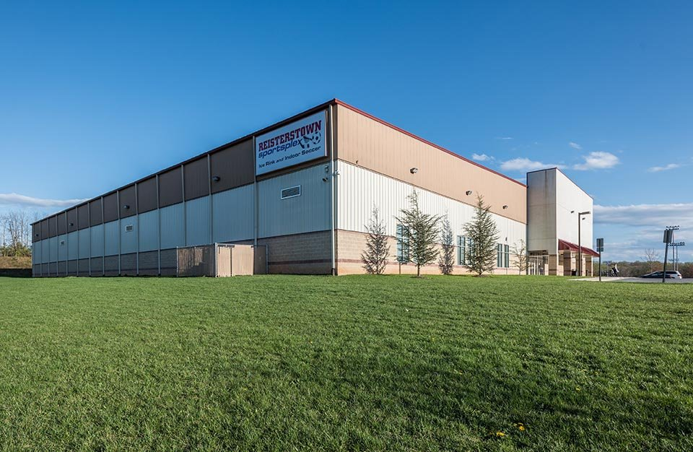
Located off campus at 401 Mitchell Dr, Reisterstown, Md 21136, this indoor ice rink is home to Ice Hockey. For more information visit Reisterstown Sportsplex Website

Inclement Weather
- In the event of an inclement weather the game Supervisor will determine when to halt play and will help direct participates and spectators to the nearest shelter for safety.
- The game Supervisor will notify officials, coaches/team captains when lighting strikes within 6 miles. Play will be halted at that time.
- Once lighting has reached 30 miles from the location of play, the game supervisor will notify both teams and referees the play may continue.

Accidents, Injuries, & Emergencies
To ensure that we provide a safe and secure environment for our participants:
- An Athletic Trainer is onsite for all competitions.
- A UMBC Supervisor is onsite for all competitions.
- Anytime a participant is injured in/at a UMBC facility a UMBC Club Sports Incident/Accident Report must be completed. In the event of an injury, please see the UMBC supervisor designated for that event. These individuals will be able to complete the Incident/Accident form and facilitate care.
- In the event of a medical emergency the Athletic Trainer on site will call campus police, 410-455-5555. Campus police will call for an ambulance.

Local Hospitals and Medical Centers
St. Agnes Hospital
900 S. Caton Ave.
Baltimore, MD 21229
667-234-6000
http://www.stagnes.org/
Hours: Open 24 hours
Driving Directions from Campus: Head west on Hilltop Rd toward Hilltop Circle. At the traffic circle, take the 1st exit onto MD-372 E/Wilkins Ave. Use any lane to turn left onto Southwestern Blvd. Continue onto Wilkins Ave, then turn right onto S. Caton Ave. The hospital will be on your left.

Patient First – Catonsville
6333 Baltimore Nationals Pike
Catonsville, MD 21228
443-514-1361
https://www.patientfirst.com/
Hours: Open from 8am to 10pm; everyday, including weekends and holidays
Driving Directions from Campus: Head west on Hilltop Rd toward Hilltop Circle. At the traffic circle, take the 1st exit onto MD-372 E/Wilkins Ave. Turn left onto Kenwood Ave. Turn left to merge onto I-695 N toward Towson. Take exit 15B to merge onto US-40 W/Baltimore National Pike toward Ellicott City. Travel 1.5 miles and destination will be on your left.

Local Attractions
Baltimore
Only 10 miles from the university, Baltimore has something for everyone. Built around the Inner Harbor, the city is a walker’s delight, with a lineup of attractions within three or four blocks of one another. More information can be found at www.baltimore.org.
Annapolis
Only 30 miles from the university, Annapolis boasts historic charm with its beautifully preserved and restored buildings and brick downtown streets. A boater’s paradise, the city ranks as the Sailing Capital of America and hosts the country’s largest in-water boat show every October. More information can be found at www.visit-annapolis.org.
Washington, DC
Only 40 miles from the university, Washington, DC, is a metropolitan city with historic attractions, museums, monuments, hotels, restaurants, free annual events, and visitor’s services unrivaled by any other American city. More information can be found at www.washinton.org.

Important Links
- UMBC Visitors Guide
- Campus Map
- Parking & Transportation Services
- UMBC Recreation Website
- UMBC Website

REQUIRED FORMS: NEXT PAGE

LIABILITY RELEASE AND ASSUMPTION OF RISK
LIABILITY RELEASE, WAIVER, DISCHARGE, AND COVENANT NOT TO SUE
- Assumption of Risk and Release from Liability\Expression of Desire to Participate: I desire to participate in the Activity (“UMBC Club Sport Event, Race, and Tournament”), to be held on and I fully understand and appreciate the dangers, hazards, and risks inherent in the Activity and any endeavors related to the Activity. Knowing the dangers, hazards, and risks of such activities, and in consideration of desiring to participate in the Activity, on behalf of myself, my family, heirs, and personal representative(s), I, the undersigned, agree to assume all risks and responsibilities surrounding my participation in the Activity; and in advance I hereby release, waive, forever discharge, and covenant not to sue UMBC and/or UMBC Rec Sports, its officers, agents, faculty, of any of the listed organizations (all of whom are collectively called “UMBC” in later references within this Agreement), from and against any and all liability for any harm, injury, damage, claims, demands, actions, causes of action, costs, and expenses of any nature that I may have or that may hereafter accrue to me, arising out of or related to any loss, damage, or injury, including but not limited to suffering and death, that may be sustained by me or by any property belonging to me, while participating in the Activity. It is my expressed intent that this assumption of risk, release and hold harmless agreement shall bind the members of my family and spouse, if I am alive, and my estate, family, heirs, administrators, personal representatives, or assigns, if I am deceased, and shall be deemed as a “Release, Waiver, discharge and Covenant” not to sue UMBC.
- Consent and Capacity to Execute Agreement. In signing this Release, I acknowledge and represent that I have fully informed myself of the content of the foregoing waiver of liability and hold harmless agreement by reading it before I sign it, and no oral representations, statements or inducements, apart from the foregoing written statement, have been made. I further state that I am at least Eighteen (18) years of age and fully competent to sign this Agreement.
- I certify that I am a registered member in good standing.

THIS IS A RELEASE OF LEGAL RIGHTS. READ AND BE CERTAIN YOU UNDERSTAND IT BEFORE SIGNING.

ACTIVITY PARTICIPANT:

PRINT NAME

SIGNATURE DATE

PRINT NAME OF PARENT OR LEGAL GUARDIAN (If participant is under 18 years old)

SIGNATURE OF PARENT OR LEGAL GUARDIAN (If participant is under 18 years old)

